American Long Rifle Forum Image Posting – IPad and IPhone

This is a tutorial for adding pictures to a post with your iPad or iPhone. Seeing the two systems are the same, I will use my IPhone for the tutorial, but they will both work the same. One note: You can take a picture with your device, or cut and paste a picture. I will show you how to take a picture and post it on the forum.

First: Log into the ALR forum and select the forum or post you would like to reply to.

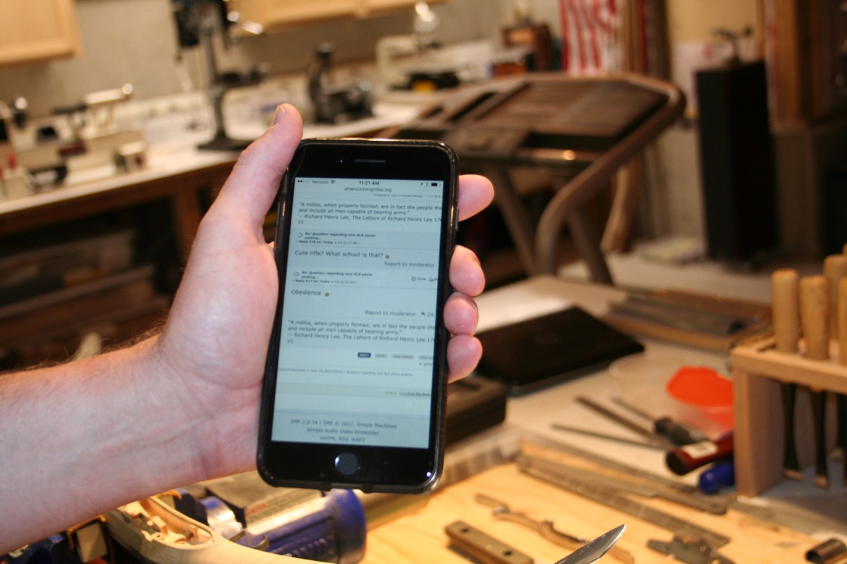

Look for the blue “Reply” button on the lower right side, under the last post. Press that button. Once you hit the reply button, you will get a screen where you can type in your text reply, then right below that screen will be the words “Add image to post” (Picture below shown is zoomed in) .
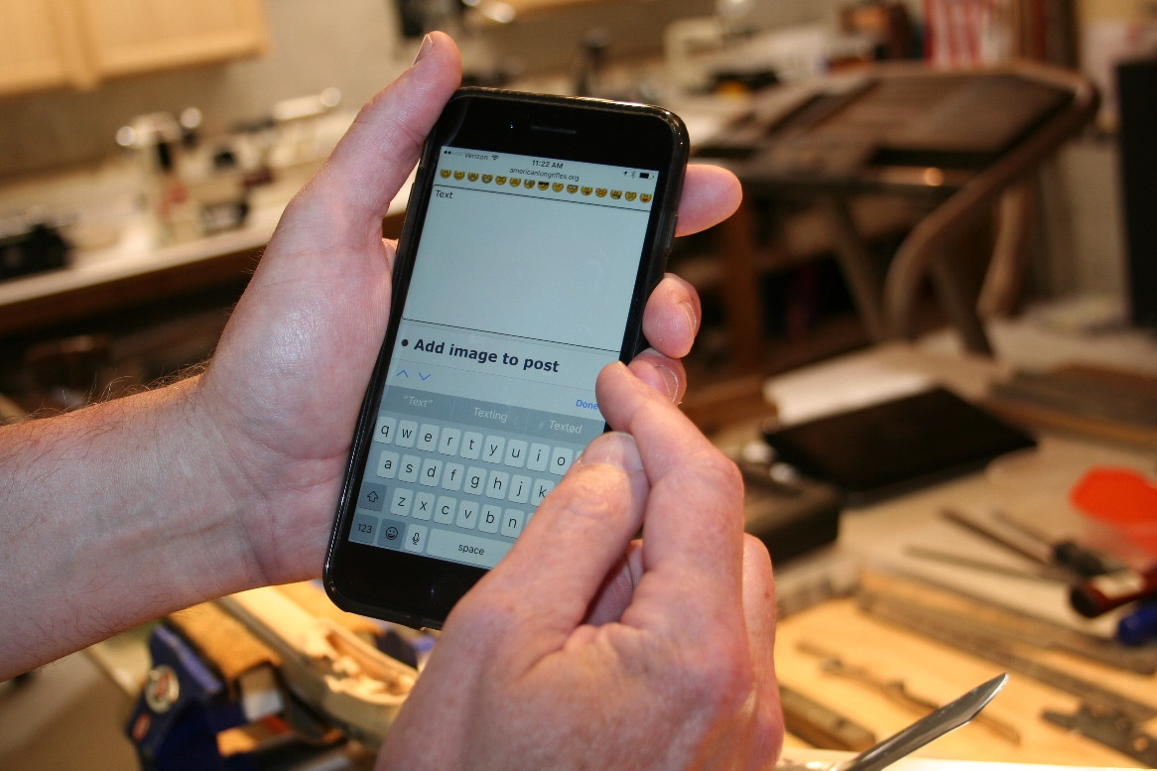

Press on (or select) that link

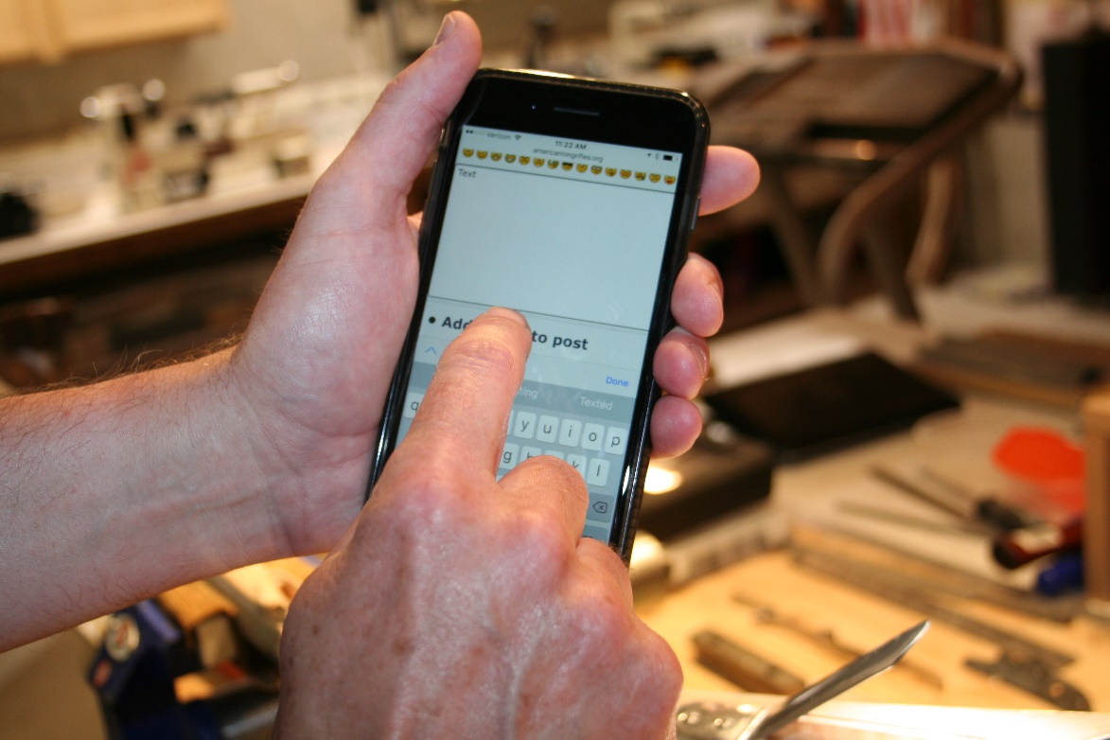

Once you select the link, you will get a new page opening from imgbb.com (See example below)
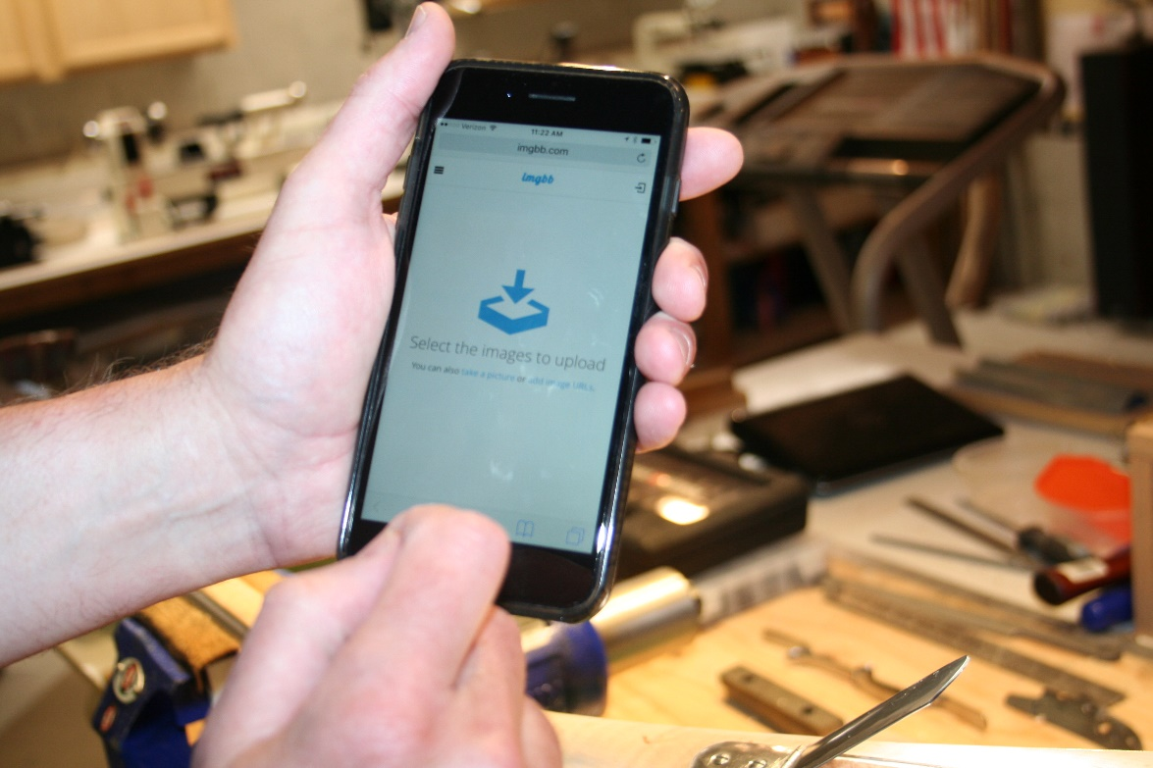

Just below the blue box, you will have a choice to click on one of two links, the first being ”Take a Picture” or you can “Add an image” In this example we will “Take a picture” so go ahead and select that link.

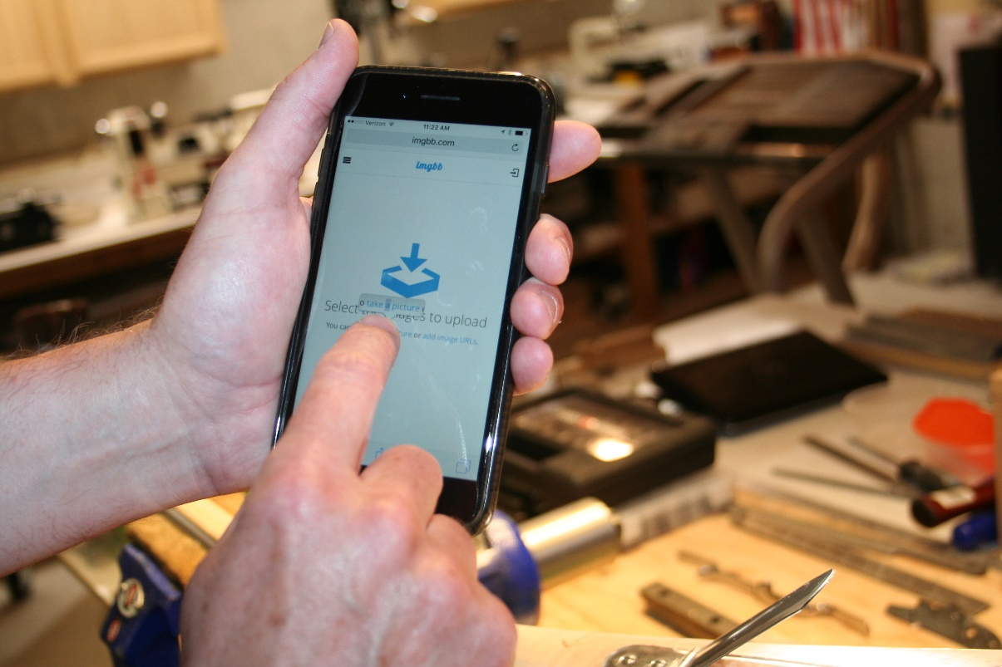

Your phone (or IPad) will go to camera mode, and you can take a picture of anything you want to post. In this example, I took a picture of a Patchbox being assembled. You can retake the picture, or you can select in the lower right corner “Use Photo”
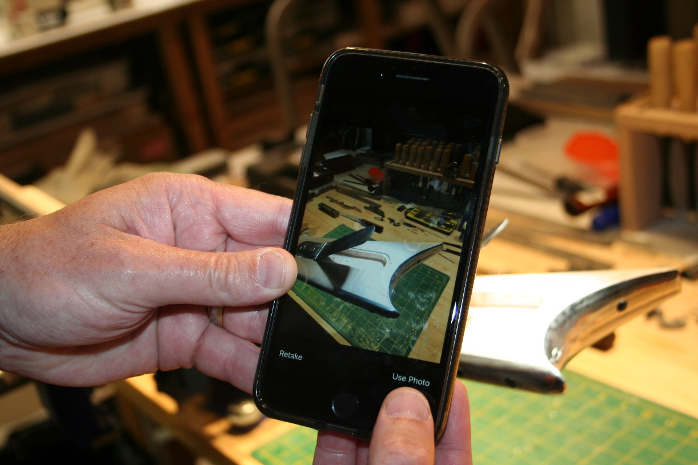
When you press “Use Photo” Your phone will switch to the upload screen, and you can either delete the picture, or press the green button, and upload the picture to your post.

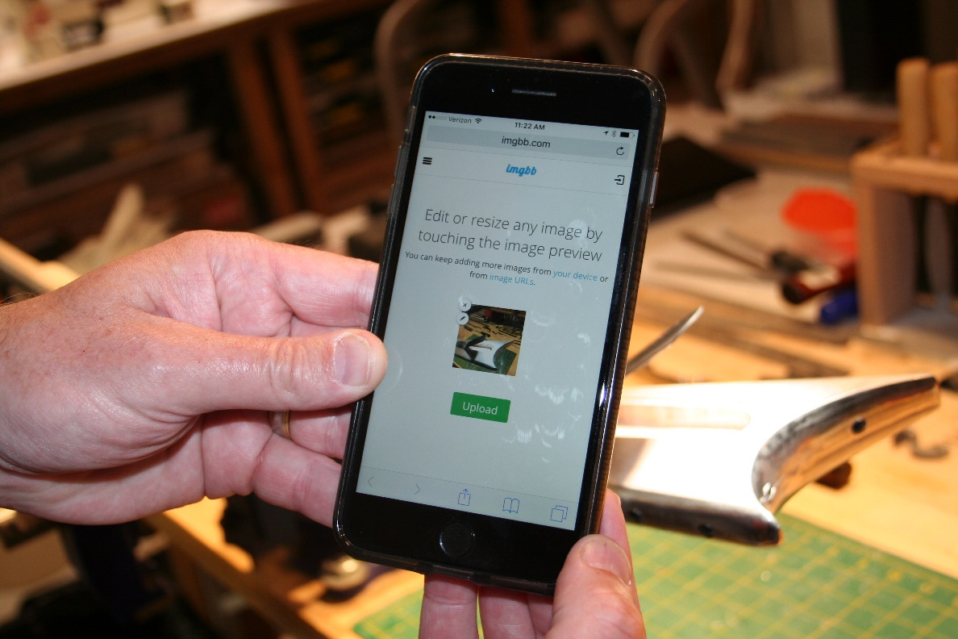
When you press the green button, It should look like this while uploading.
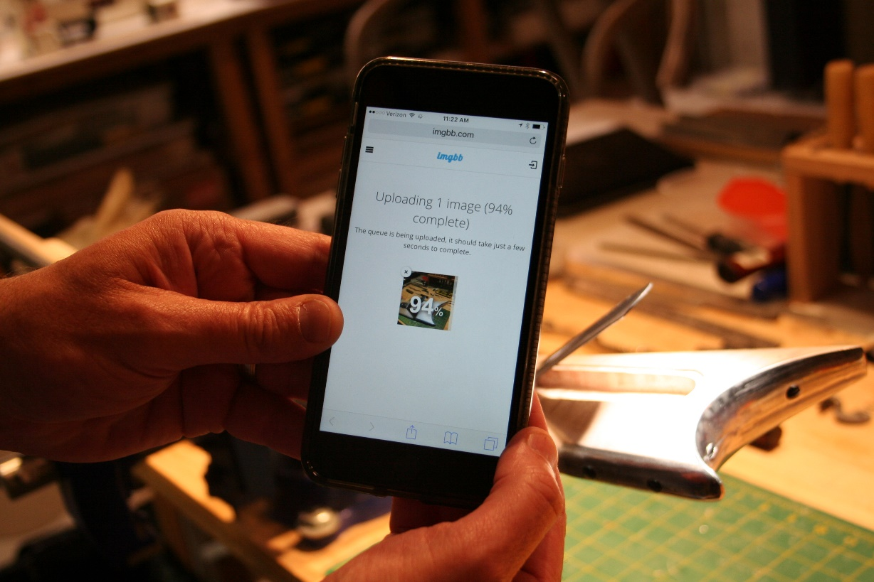

You will now see he image link in your post under the text you have already entered.

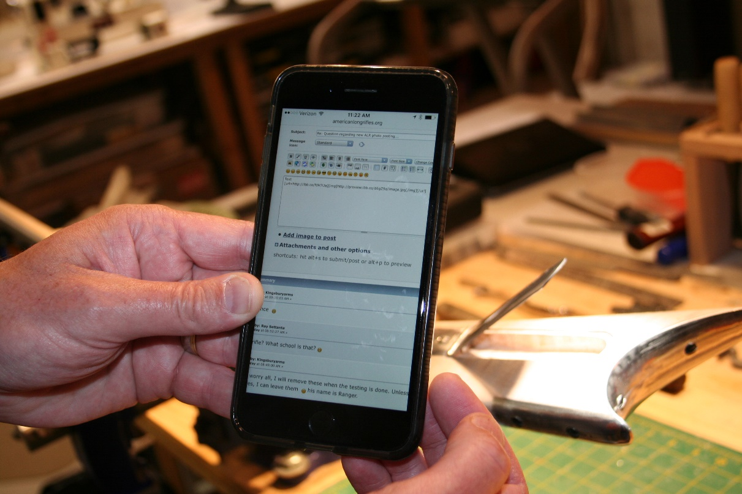
You can preview your post by pressing the preview button, or just post the reply. Here is a preview example:
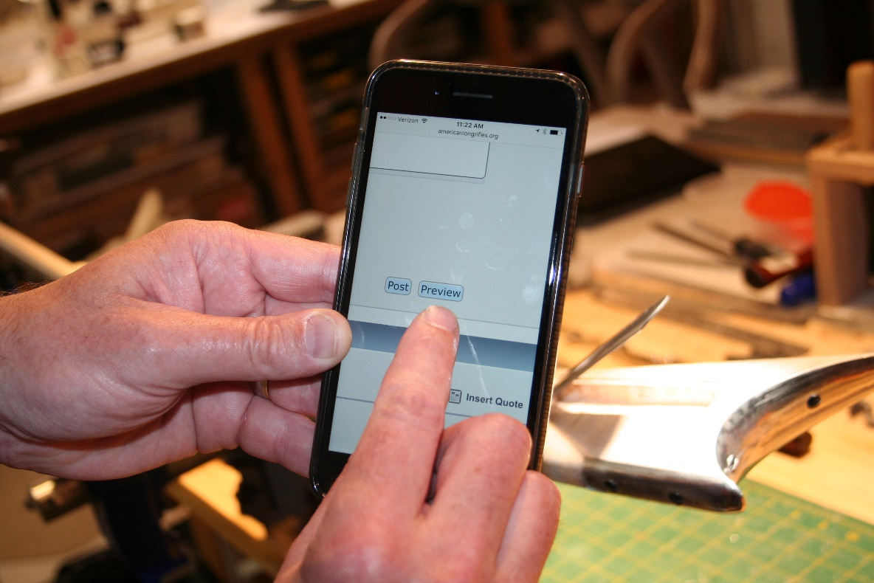
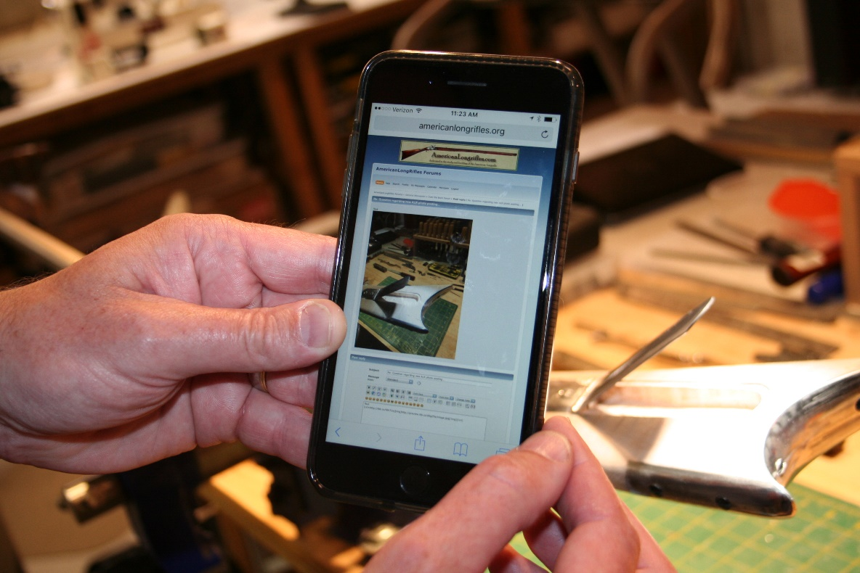

If you like what you see, then you can just tap on “Post” and you are all set!

IPads work exactly the same way!!!

